Creating a Digital Filter in C from a Discrete Transfer Function

You can create a C digital filter from a discrete transfer function by converting the math equation into a difference equation and writing code to store past input and output values
.
Steps to Create a Digital Filter in C
1. Get the Difference Equation
- Write your transfer function in terms of the Z-transform, usually shown as \(H(z) = \frac{Y(z)}{X(z)} = \frac{b_0 + b_1 z^{-1} + b_2 z^{-2}}{1 + a_1 z^{-1} + a_2 z^{-2}}\).
- Cross-multiply to move Y(z) and X(z) back to the time domain.
- Solve for the current output \(y[n]\):
\(y[n] = b_0 x[n] + b_1 x[n-1] + b_2 x[n-2] - a_1 y[n-1] - a_2 y[n-2]\)
2. Set Up the C Code Structure
- Create an array or state variables to save past inputs (\(x[n-1]\), \(x[n-2]\)) and past outputs (\(y[n-1]\), \(y[n-2]\)).
- Write a function that runs each time you get a new sample input.
3. Example C Code for a Biquad (2nd-Order) Filter
c
#stdio.h> // Include standard I/O (add # at the start)

typedef struct {
float b0, b1, b2; // Feedforward coefficients
float a1, a2; // Feedback coefficients
float x1, x2; // Past inputs
float y1, y2; // Past outputs
} Filter;

float filter_step(Filter *f, float x0) {
// Calculate current output
float y0 = f->b0 * x0 + f->b1 * f->x1 + f->b2 * f->x2
- f->a1 * f->y1 - f->a2 * f->y2;

// Shift past inputs
f->x2 = f->x1;
f->x1 = x0;

// Shift past outputs
f->y2 = f->y1;
f->y1 = y0;

return y0;
}
Use code with caution.
4. How to Use It in Your Program
- Initialize your filter coefficients (b and a values) based on your specific cutoff frequency and filter type (like Butterworth or FIR).
- Set all past state variables (x₁, x₂, y₁, y₂) to zero before starting.
- Call filter_step(&my_filter, new_input_sample) inside your main processing loop.
If you can share your specific transfer function coefficients or tell me the type of filter you need (Low-pass, High-pass), I can help you write the exact initialization code.

Please show the steps involved in Cross-multiply to move Y(z) and X(z) back to the time domain.
Here are the step-by-step algebraic moves to convert your Z-domain transfer function into a time-domain difference equation.
1. Set Up the Rational Equation
Start with the definition of the transfer function \(H(z)\), which is the ratio of the output \(Y(z)\) to the input \(X(z)\):
\(\frac{Y(z)}{X(z)}=\frac{b_{0}+b_{1}z^{-1}+b_{2}z^{-2}}{1+a_{1}z^{-1}+a_{2}z^{-2}}\)
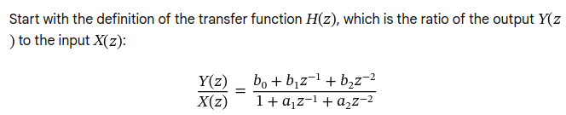
2. Cross-Multiply
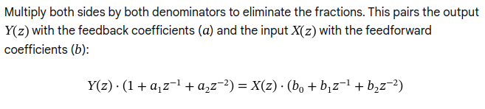
3. Distribute \(Y(z)\) and \(X(z)\)
Multiply the terms through the parentheses on both sides of the equation:

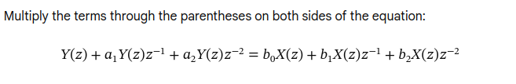
4. Apply the Inverse Z-Transform (Time Shift Property)
To move back to the time domain, use the core property of the Z-transform: multiplying a signal by \(z^{-k}\) in the Z-domain equals delaying that signal by \(k\) samples in the time domain.
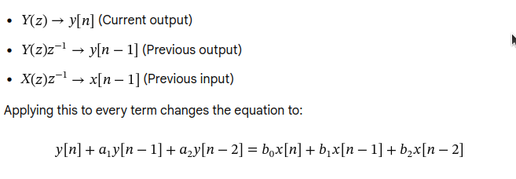

5. Isolate the Current Output \(y[n]\)
Subtract the past output terms (\(y[n-1]\) and \(y[n-2]\)) from the left side to isolate \(y[n]\). This gives you the final difference equation used directly in your C code:
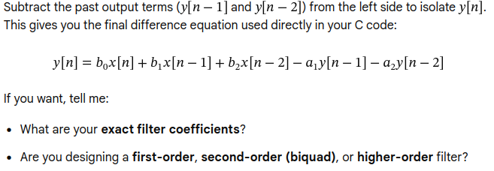
If you want, tell me:
- What are your exact filter coefficients?
- Are you designing a first-order, second-order (biquad), or higher-order filter?
I can help you map your exact math directly into your C arrays.

